**MP PROJECT FINAL REPORT**

Vth SEM E&C

**Bluetooth Controlled Robot Using 8051**

**Electronics and Communication Engineering**

*Submitted by*

|  |  |  |
| --- | --- | --- |
| **Student Name:** | **Registration No.:** | **Section-Roll No.:** |
| **Virupaaksh Vivek Lakhotia** | **190907234** | **B1 - 1** |
| **Jason Pereira** | **200907008** | **B1- 2** |
| **Ark Verma** | **200907126** | **B1 - 20** |
| **Manas Choudhary** | **200907154** | **B1 - 22** |

 **DEPARTMENT OF ELECTRONICS AND COMMUNICATION ENGINEERING**

**MANIPAL INSTITUTE OF TECHNOLOGY**

(A Constituent Institution of Manipal Academy of Higher Education)

MANIPAL – 576104, KARNATAKA, INDIA

**AUGUST 2022**

**ABSTRACT**

Robots are generally defined as an electro-mechanical machine, which we can guide through electric signals and computer programming. Nowadays, they have taken the world by storm, with multiple robots being built for innumerable tasks. In our project we have decided to foray into the field of robotics by attempting to build a Bluetooth controlled robot using 8051 microcontrollers and Bluetooth module. The robot is designed using DC motors and the direction of DC motors will be controlled by the commands received from the android application. The status of the robot is sent back to the Android app affiliated with HC-05 module, which is a Bluetooth module that be used as an interface to communicate with the robot.

**PROJECT DETAILS**

**Block Diagram:**

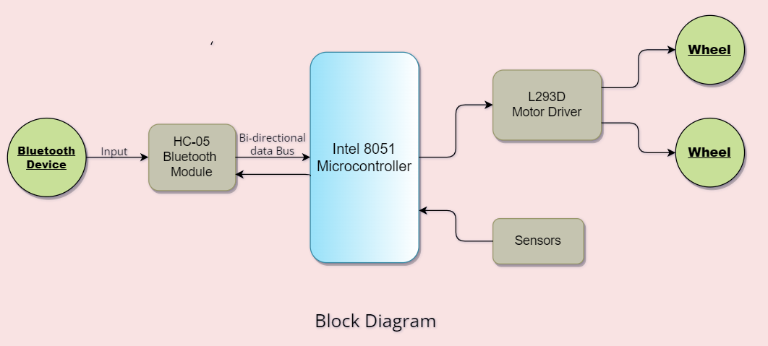

*Block Diagram of Bluetooth controlled robot*

Our Bluetooth controlled robot works with the aid of 8051 microcontroller, which in turn is connected to a motor driver. Motor drivers are an important part of the project, as direct connection of motor to the microcontroller is not enough to power the wheels (due to current in the microcontrollers being in mA). The commands will be given through a Bluetooth equipped device, (usually our phones), to HC-05 module, which allows Bluetooth connection between the microcontroller and the user. In addition to that, data collected through the sensors can also be sent back to the user through the module.

**Components required:**

Hardware:

1. Intel 8051(AT89S52) microcontroller
2. L293D motor driver
3. HC-05 Bluetooth module
4. 2 DC motors (5V)
5. 2 Wheels
6. Robot chassis
7. Ultrasonic Sensor
8. Wires
9. Any Bluetooth equipped device

Software:

1. HC-05 Bluetooth terminal app
2. Keil MDK (µVision IDE)

**CODE:**

**SIMULATIONS:**

**RESULTS:**

(command table; outcomes)

**REFERENCES:**

1. <https://circuitdigest.com/microcontroller-projects>
2. <https://online.visual-paradigm.com/app/diagrams>
3. <https://robotics.stackexchange.com/>
4. <https://www2.keil.com/mdk5/learn>